Experiment No.7
Name :-Shivani Kolekar
Roll No:-24141031
Batch:-I2
Title:- Tptimal binary search using dynamic Programming
Programm:-
#include <stdio.h>
#include <limits.h> // For INT_MAX
#define MAX 20 // Maximum number of keys
// Function to find the Optimal BST
void optimalBST(float p[], float q[], int n) {
float e[MAX + 1][MAX + 1]; // Expected cost
float w[MAX + 1][MAX + 1]; // Weight sums
int root[MAX + 1][MAX + 1]; // Root table
// Initialize tables
for (int i = 1; i <= n + 1; i++) {
e[i][i - 1] = q[i - 1];
w[i][i - 1] = q[i - 1];
}
// Build tables for increasing lengths
for (int l = 1; l <= n; l++) {
for (int i = 1; i <= n - l + 1; i++) {
int j = i + l - 1;
e[i][j] = INT_MAX;
w[i][j] = w[i][j - 1] + p[j] + q[j];

for (int r = i; r <= j; r++) {
float t = e[i][r - 1] + e[r + 1][j] + w[i][j];
if (t < e[i][j]) {
e[i][j] = t;
root[i][j] = r;
}
}
}
}
// Print results
printf("\nMinimum expected search cost = %.4f\n", e[1][n]);
printf("\nRoot matrix (showing optimal root for each subtree):\n");
for (int i = 1; i <= n; i++) {
for (int j = i; j <= n; j++) {
printf("root[%d][%d] = %d\n", i, j, root[i][j]);
}
}
}
int main() {
int n = 3; // number of keys
// Probabilities of successful searches
float p[] = {0, 0.15, 0.10, 0.05}; // 1-indexed (p[0] unused)
// Probabilities of unsuccessful searches
float q[] = {0.05, 0.10, 0.05, 0.05};
printf("Optimal Binary Search Tree Problem\n");
printf("----------------------------------\n");
printf("Number of keys = %d\n", n);
optimalBST(p, q, n);
return 0;
}
Output:- 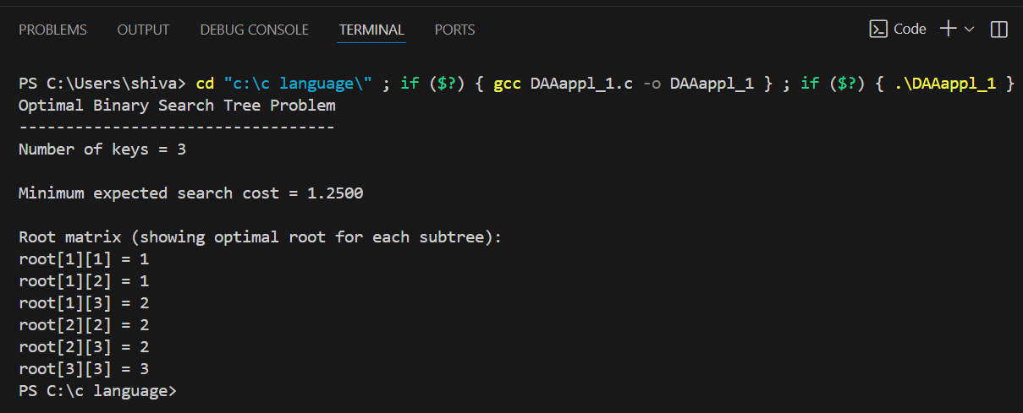

Complexity
- Time: O(n³)
- Space: O(n²)
Applications of Optimal Binary Search Trees (OBST)
1. Efficient Searching in Static Databases
- When you know how frequently each key is accessed, an OBST minimizes the average search time.
- Example:
  - A dictionary or word list used in a spell-checker.
  - Searching for reserved words in a compiler (like if, else, for, etc.).
- If some keys (words) are looked up more often, OBST ensures they appear closer to the root, making searches faster on average.

2. Compiler Design – Keyword Lookup
- Compilers often need to recognize reserved keywords (e.g., int, while, return, if).
- Since some keywords appear more frequently than others, compilers use OBSTs to minimize the average number of comparisons during lexical analysis.

3. Data Compression and Encoding
- OBSTs can be used to assign shorter search paths to frequent symbols, similar in spirit to Huffman coding.
- Used when you have to decide a binary decision structure minimizing weighted cost.

4. Information Retrieval Systems
- In search engines or document databases, OBSTs can improve query response time when certain terms or files are accessed more frequently.

5. Optimal Storage and Access of Static Data
- When the data set does not change often (static), and access probabilities are known, OBSTs provide the most efficient tree structure for retrieval.
- Example:
  - Lookup tables in embedded systems.
  - Static routing tables or configuration tables.

6. Predictive Text and Autocomplete Systems
- When a predictive text model knows the probability of each word or phrase, an OBST can minimize the average number of comparisons or lookups required.

Conclusion:- The Optimal Binary Search Tree (OBST) uses Dynamic Programming to build a BST that minimizes the average search cost based on known access probabilities. It ensures faster lookups in static search applications like compilers and databases.

